http://www.javatpoint.com/static-keyword-in-java
http://beginnersbook.com

Building blocks of Opps

Object: any entity having its own properties and functions

Class: Collection of properties and common functions which can be acquired by similar objects.
Ex. Each Car having properties like color, manufacturing year, model and performs common functions like stop, start, move etc. We can create several instances of class car like alto, wagnor etc.

Four Pillars of OOPS:

- Inheritance: Parent child relation, I acquire properties of my father like home, vehicle as well as I have my own properties profession, salary.

- Polymorphism: We act different infornt of parent and differently in front of friend so same person is behaving differently at different situation/time.

Women mother of two is also daughter if someone and sister, so same person performs different tasks.

- Abstraction: hiding the implementation for outside world and showing only functions.
Ex: Tv Remote control which acts as interface between tv and user, we just press buttons we don’t know what happens at internal circuit of remote and within tv.

Another example would be Yahoo email, we just see inbox, sent, compose attach options and we use them to perform appropriate actions but user don’t have to know what actual functions are called or in other words what actual logical code is written to perform those functions.

- Encapsulation: Best example of encapsulation is a class. We actually hide data and implementation by performing abstraction and data hiding. Various access modifiers are implemented for data hiding purpose.

Run time polymorphism Ex (Note: Always call if made according to instance call ; not reference during defining object)

E.g.: Parent obj = new Child();

Here Parent class’s reference is given (“Parent”). However Constructor of Child Class is classed. So all Over-ridden methods of Child class will be called. Now, if there are any non-overridden methods from parent, they can also be called since reference is of Parent class and inheritance is made.

package practice;

Bike.java
package practice;

public class Bike {
public void run(){
System.out.println("Printed from Bike");
}
}

DemoOne.java

public class DemoOne extends Bike{

public void run(){
System.out.println("Printer from Demo one bhai");
}
public static void main(String[] args) {
// TODO Auto-generated method stub

//Bike a = new Bike();
//DemoOne b = new DemoOne();
//Bike c = new Bike();
Bike d = new DemoOne();
//a.run();
//b.run();

//c.run();
d.run();
}

}

Output:
Printer from Demo one bhai

To call methods from other call within same package;

package practice;

Bike.java
package practice;

public class Bike {
public void run(){
System.out.println("Printed from Bike");
}
}

CallMethodWithinSamePackage.java

package practice;

public class CallMethodWithinSamePackage {

public void run(){
System.out.println("Printed from Called Class bhai");
}
public static void main(String[] args) {
// TODO Auto-generated method stub

Bike d = new Bike();

d.run();

CallMethodWithinSamePackage obj = new CallMethodWithinSamePackage();

obj.run();

//prints output from run of other class in same package
}

}

Printed from Bike
Printed from Called Class bhai

=====
Program tricks do from below site (refer to Eclipse Neon existing programs)
http://sampleprogramz.com/java/tricks.php

Access Modifiers Decision Table:

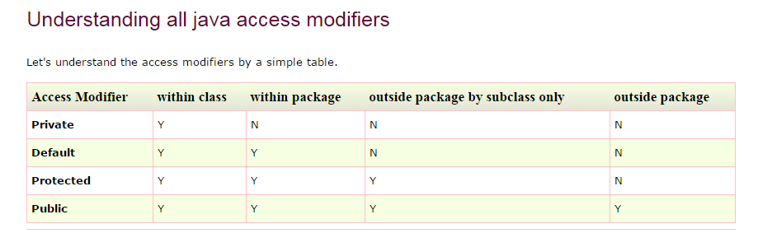

- Private is lowest.
- Default is limited till within package.
- Protected limited within package, only exception is subclasses of a class outside package can use.
- Public is highest access anywhere anytime.

Static Keyword:

- Anything owned by a class is defined as static.
- They are initialized as soon as class is loaded.
- Static variables can be accessed directly, and holds value (e.g. counter) throughout execution.
- Static methods can be access without object of class. If has to be called from outside of class, classname can be used to access static variable.
- To define a variable as constant in java, it has to defined as public static final int MY_CONSTANT = 0;
It can be accessed easily using classname.MY_CONSTANT;

Abstract Class:

E.g. public abstract class Demo {

Public void walk();

Public void dance(){

//
Statements
}
}

Key Points:

- An abstract class has no use until unless it is extended by some other class.
- If you declare an abstract method (discussed below) in a class then you must declare the class abstract as well. you can’t have abstract method in a non-abstract class. It’s vice versa is not always true: If a class is not having any abstract method then also it can be marked as abstract.
- Abstract class can have non-abstract method (concrete) as well.

Abstract methods

Well, we already discussed about abstract methods in the above section. Lets take few examples to understand it better.

syntax:

public abstract void display();

Points to remember about abstract method:
1) Abstract method has no body.
2) Always end the declaration with a semicolon(;).
3) It must be overridden. An abstract class must be extended and in a same way abstract method must be overridden.
4) Abstract method must be in a abstract class.

Note: The class which is extending abstract class must override (or implement) all the abstract methods.

Example of Abstract class and method

abstract class Demo1{
public void disp1(){
System.out.println("Concrete method of abstract class");
}
abstract public void disp2();
}

class Demo2 extends Demo1{
/* I have given the body to abstract method of Demo1 class
It is must if you don't declare abstract method of super class
compiler would throw an error*/
public void disp2()
{
System.out.println("I'm overriding abstract method");
}
public static void main(String args[]){
Demo2 obj = new Demo2();
obj.disp2();
}
}
Output:

I'm overriding abstract method

Interfaces

Key points: Here are the key points to remember about interfaces:
1) We can’t instantiate an interface in java.

2) Interface provides complete abstraction as none of its methods can have body. On the other hand, abstract class provides partial abstraction as it can have abstract and concrete(methods with body) methods both.

3) implements keyword is used by classes to implement an interface.

4) While providing implementation in class of any method of an interface, it needs to be mentioned as public.

5) Class implementing any interface must implement all the methods, otherwise the class should be declared as “abstract”.

6) Interface cannot be declared as private, protected or transient.

7) All the interface methods are by default abstract and public.

8) Variables declared in interface are public, static and final by default.

interface Try
{
int a=10;
public int a=10;
public static final int a=10;
final int a=10;
static int a=0;
}
All of the above statements are identical.

9) Interface variables must be initialized at the time of declaration otherwise compiler will through an error.

interface Try
{
int x;//Compile-time error
}
Above code will throw a compile time error as the value of the variable x is not initialized at the time of declaration.

10) Inside any implementation class, you cannot change the variables declared in interface because by default, they are public, static and final. Here we are implementing the interface “Try” which has a variable x. When we tried to set the value for variable x we got compilation error as the variable x is public static final by default and final variables can not be re-initialized.

class Sample implements Try
{
public static void main(String args[])
{
x=20; //compile time error
}
}
11) Any interface can extend any interface but cannot implement it. Class implements interface and interface extends interface.

12) A class can implement any number of interfaces.

13) If there are two or more same methods in two interfaces and a class implements both interfaces, implementation of the method once is enough.

interface A
{
public void aaa();
}
interface B
{
public void aaa();
}
class Central implements A,B
{
public void aaa()
{
//Any Code here
}
public static void main(String args[])
{
//Statements
}
}
14) A class cannot implement two interfaces that have methods with same name but different return type.

interface A
{
public void aaa();
}
interface B
{
public int aaa();
}

class Central implements A,B
{

public void aaa() // error
{
}
public int aaa() // error
{
}
public static void main(String args[])
{

}
}
15) Variable names conflicts can be resolved by interface name e.g:

interface A
{
int x=10;
}
interface B
{
int x=100;
}
class Hello implements A,B
{
public static void Main(String args[])
{
// reference to x is ambiguous both variables are x
System.out.println(x);
System.out.println(A.x);
System.out.println(B.x);
}
}
Benefits of having interfaces:

Following are the advantages of using interfaces:

Without bothering about the implementation part, we can achieve the security of implementation
In java, multiple inheritance is not allowed, However by using interfaces you can achieve the same . A class can extend only one class but can implement any number of interfaces. It saves you from Deadly Diamond of Death(DDD) problem.

Singleton Class –Design Pattern

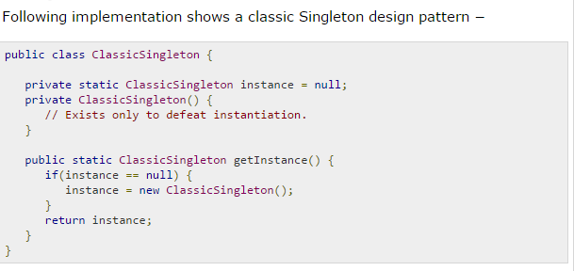

The ClassicSingleton class maintains a static reference to the lone singleton instance and returns that reference from the static getInstance() method.
Here, ClassicSingleton class employs a technique known as lazy instantiation to create the singleton; as a result, the singleton instance is not created until the getInstance() method is called for the first time. This technique ensures that singleton instances are created only when needed.

===

